Do you want to learn how to sign?
Do you want to learn how to minister to hard of hearing and/or Deaf people?

THIS IS THE PLACE FOR YOU!
Jesus Signs Immersion at Immanuel Lutheran in St. Charles, MO.
Come join us July 22-26, 2024!!

Come join us for an Immersion experience that will equip you and give you the resources you need!

For more information check out - DeafOutreach.org
Please pray for and share this prayer list with others:

Thank you for partnering with Deaf Outreach as we train people to reach the 98% of Deaf people and their families who do not believe in Jesus. We want them all in Heaven!!

God Bless you as we serve Jesus Together!

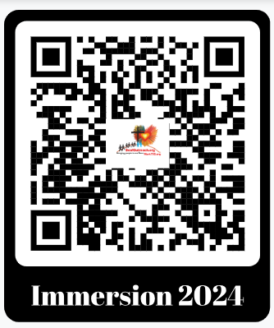
Deaf Outreach
PO Box 283
St. Charles, MO 63302

For more information contact:
Rev. Dr. John Reinke
608-436-9600
RevReinke@gmail.com
DeafOutreach.org

